 Project Design Phase

Solution Architecture – ShopEZ
Date | 27 January 2026
Team ID | LTVIP2026TMIDS28465
Project Name | ShopEZ: One-Stop Shop for Online Purchases
Maximum Marks | 4 Marks

Solution Architecture Description
The ShopEZ solution architecture bridges the gap between the business challenges of fragmented online shopping and the technical implementation of a unified, scalable ecommerce platform.
It is designed using the MERN stack (MongoDB, Express.js, React.js, Node.js), ensuring a modern, full-stack JavaScript environment that supports rapid development and scalability.

Goals of the Solution Architecture
- Identify the best tech stack to solve the problem of disconnected buyer-seller experiences
- Define the structure and behavior of the ShopEZ platform, including frontend, backend, and database layers
- Outline key features such as personalized product feeds, seller dashboards, secure checkout, and multilingual support
- Break down development phases into modular sprints (e.g., user auth, product catalog, cart & checkout, analytics)
- Provide clear specifications for APIs, data models, and user flows to guide development and stakeholder alignment

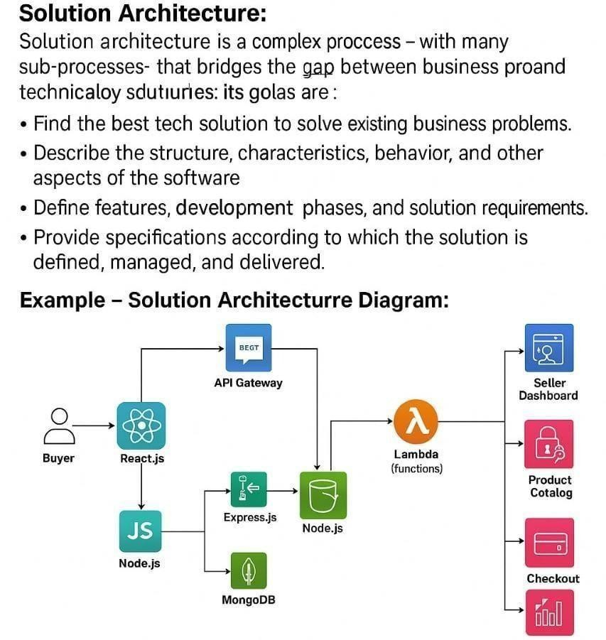

Reference: https://github.com/damesh13/shopez-one-stop-shop-for-online-purchases

